**2.NUCLEAR DETECTION USING RASPBERRY SENSOR**

SCHEMATIC LAYOUT:-

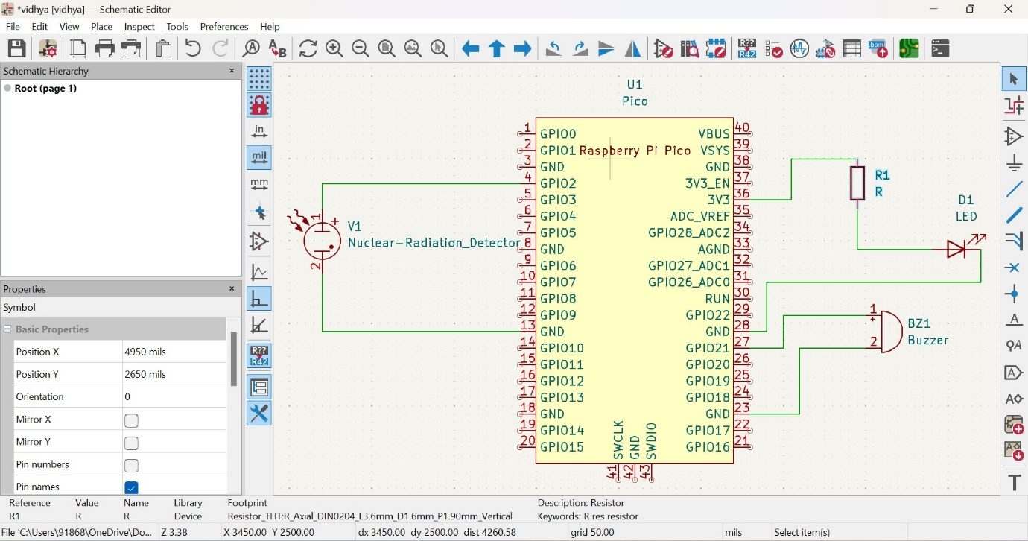

PCB LAYOUT:-

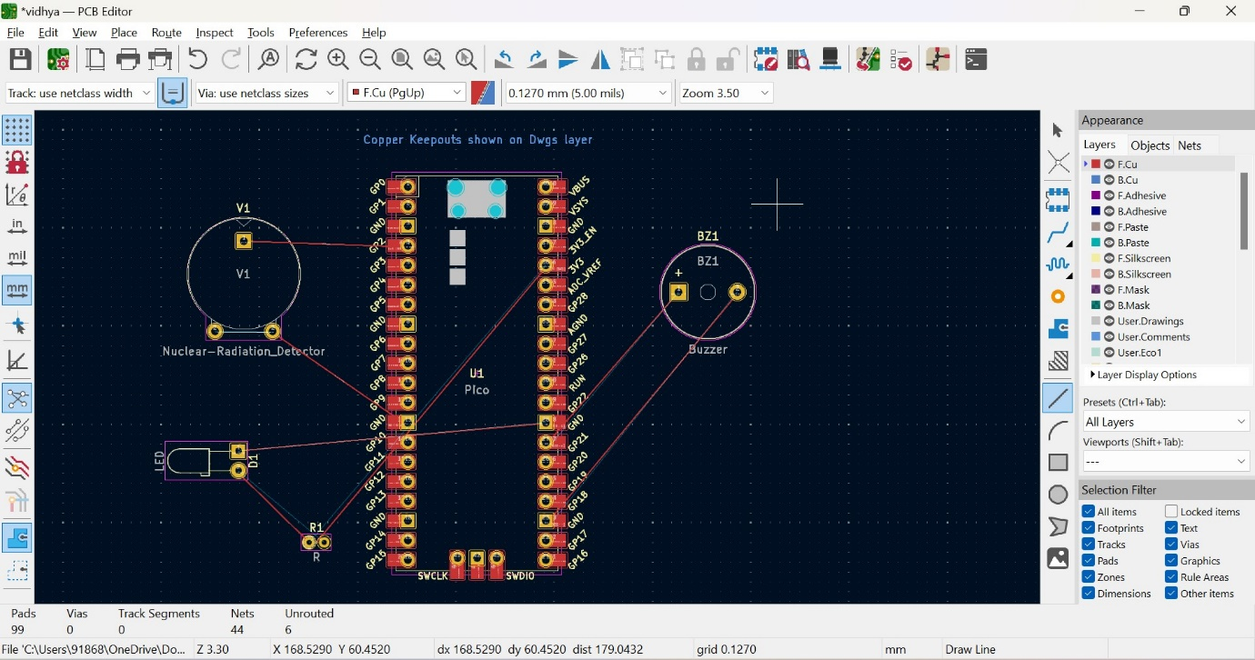

3D VIEW OF PCB LAYOUT:-

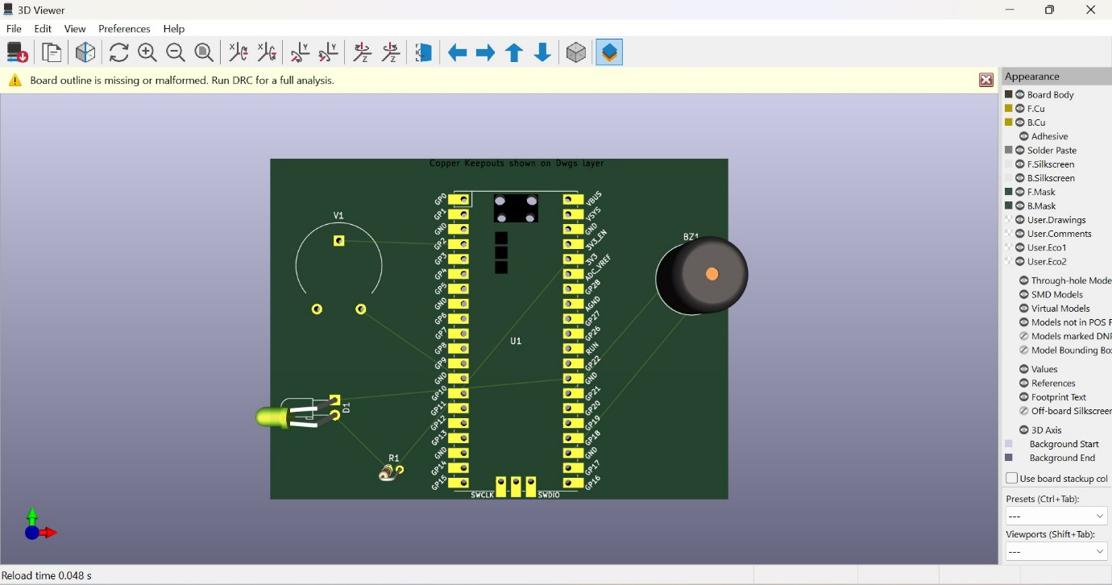

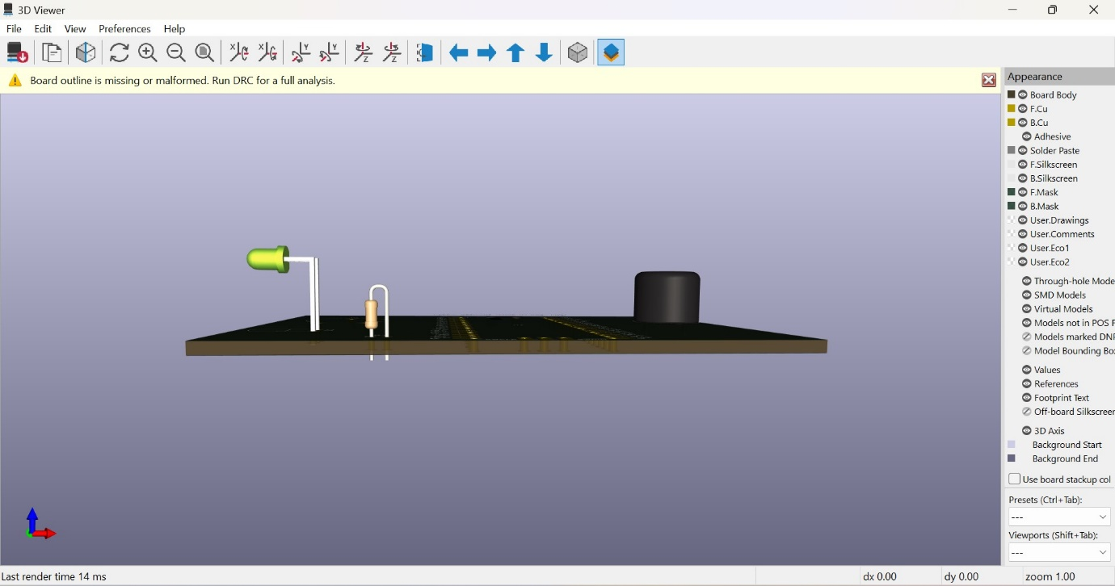

PIN LAYOUT:-

